**BSBA AY 2015-2016 Assessment**

***Phase 1: Assessment Plan***

**Learning Outcome assessed:**

**BSBA Learning Outcome 3: Communication**Effectively communicate orally and in writing using various mediums across unique situations.

**Assessment Method:**

Group projects in BUS 308

**Targeted performance, based on rubrics:**

80% of the students should meet or exceed expectations on the rubric’s criterium assessing this learning outcome.

**Evaluation Process:**

During the spring semester of 2016, 72 students from two sections of the core business course Systems in Organizations were put into multiple teams of three or four students and participated in three case studies and four simulations (the teams were assigned sequentially, not concurrently). Early in the semester, the students’ knowledge and understanding was scaffolded with three case studies focused on three foundational course concepts: forecasting, inventory planning, and process analysis. The students were required to submit a case analysis for two of the three case studies (forecasting and inventory planning) and a write-up on each simulation after each of the four simulations was completed.

The write-ups were group projects, however, each student had the opportunity to improve their grade by submitting rewrites for each case analysis and simulation write-up.

Written communication was assessed using a writing rubric (see below). The rubric was used for both the case analyses as well as the four simulation write-ups.

For BSBA Learning Outcome #3, the student learning outcome for written communication was first found by averaging the score of the group write-ups from the first three simulation write-ups (the fourth write-up was excluded as there was a time crunch at the end of the semester and the write-up was not representative of students’ work.) The average was formed from a student’s work that spanned two different teams. By averaging a student’s scores from two teams, an attempt was made to tease out individual learning outcomes. For example, if the top score of a student’s written work exceeded expectations in one group, it might have been because a teammate had excellent writing skills. The student’s written work in another team was looked at to try to tease out individual performance. If a student’s average written assessment score is below expectations, even though it may have met or exceeded expectations on one assignment, it is deemed that the student has writing skills below expectations.

All of the students had the opportunity to turn in individual rewrites for each of the cases and simulation write-ups to improve their grades. If a student took advantage of this opportunity for the third simulation write-up, how the student’s written performance may have improved was also analyzed.

**Rubric:**

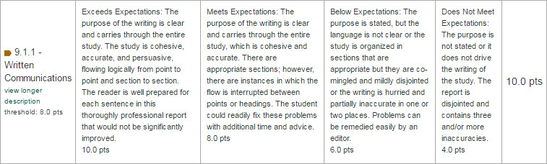

**Courses where learning outcome was assessed:**

BUS 308 Systems in Organizations

**Evaluator(s):**

Stephen Morris

***Phase 2: Results Assessment and Planned Action***

**Results:**

The following results were found by using the average written communication scores on three group written assignments:

* 12.5% of the students (9/72) met or exceeded expectations on written communications.
* 87.5% of the students (63/72) were below expectations on written communications.

When the learning outcome from individual rewrites from simulation 3 is included in the results, the numbers change to the following (the improvement in student learning outcomes is a very good indicator of the efficacy of rewrites.) Fewer than half of the students actually turned in rewrites for the third simulation (30/72) as they were optional in the course. Several of the students had already met or exceeded expectations in their written work and were not included in the additional numbers, however, eight of 27 students (29.6%) who had been below expectations showed significant improvement in their written communication learning outcomes in their simulation #3 individual rewrite. When those eight students are included in the results, we have the following:

* 23.6% of the students (17/72) met or exceeded expectations on written communications.
* 76.4% of the students (55/72) were below expectations on written communications.

**What did we learn about student learning?**

The writing skills of business students needs to improve. Within BUS 308, course improvements would include requiring the students to rewrite the case analyses and simulation write-ups. There is ample evidence in educational research that demonstrates rewriting is perhaps the most salient aspect of developing and honing writing skills.

**Suggested Action:**

In the broader framework of the BSBA program, it is necessary to have rubrics that assess the writing skills of the students as they wend their way through the entire program. Cases may already be assigned in many courses, but faculty need to understand the importance of assessing writing skills in every core course on many of the assignments, as well as be trained on how to do so. These skills not only align with AACSB standards 9.1.1 – Written Communications, but also with the WSCUC core competency of Written Communication.

**Closing the Loop:**

This outcome is scheduled to be re-assessed in AY 17/18.

**Addendum: Rubrics used for this evaluation**



BUS 406 Content Rubric

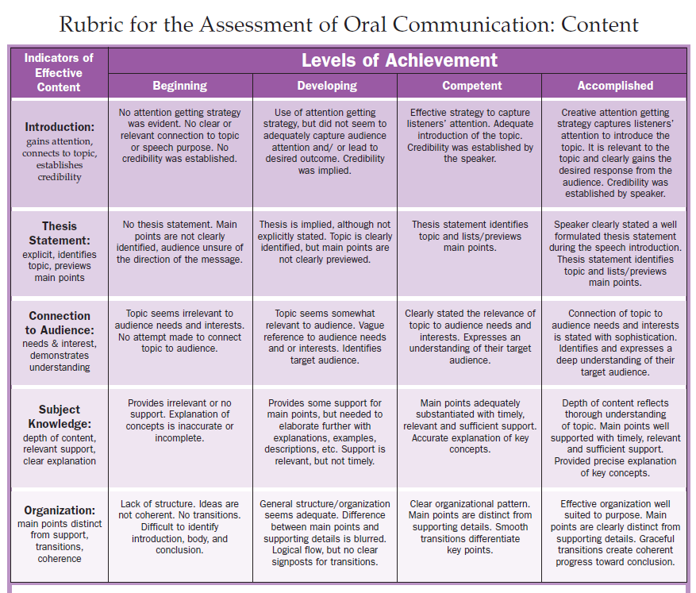

BUS 406 Delivery Rubric

