BSBA AY 2015-2016 Assessment
Phase 1: Assessment Plan
Learning Outcome assessed:
BSBA Learning Outcome 3: Communication
Effectively communicate orally and in writing using various mediums across unique situations.
Assessment Method:
Final Project Presentation in the BSBA Capstone Courses BUS 401 and BUS 406
Targeted performance, based on rubrics:
80% meet expectations
Evaluation Process:
Final presentations were scored by a team of evaluators using a 4 point rubric. The rubrics used BUS 401 and 406 were different. Samples are attached to this report. In BUS 401 the rubric is broken out in to 4 categories; Organization, Language, Delivery, and Central Message. Note that the attached rubric also contains a Supporting Material category that was not evaluated. In BUS 406 the rubric is broken out in to two sections; Content (Introduction, Thesis, Connection, Subject, and Organization) and Delivery (Eye Contact, Movement, Voice, and Fluency).
Rubrics:
3 rubrics were applied to this evaluation. See addendum (p6-8) for details.
Courses where learning outcome was assessed:
BSBA Capstone Courses BUS 401 s1-4 and BUS 406 s2
Evaluator(s):
In BUS 406 eight external judges, mostly VCs, evaluated the content and viability components of the BUS406 students' work as a whole. In BUS 401 3-4 external evaluators (including SOM professor Stephen Morris) judged the content and viability components of the BUS401 students' work.

Phase 2: Results Assessment and Planned Action
Results:
BUS 401 Oral Rubric Results
Number of students achieving target
Categories: | Exceeds Expectations | Meets Expectations | Below Expectations | Novice |  | % Students Meeting or Exceeding Expectations
 | = 4 | 3 - 4 | 2 - 3 | < 2
Organization | 3 | 69 | 35 | 0 |  | 67%
Language | 4 | 51 | 52 | 0 |  | 51%
Delivery | 3 | 37 | 65 | 2 |  | 37%
Supporting Material | 4 | 75 | 28 | 0 |  | 74%

BUS 406 Content Rubric Results
Number of students achieving target
Categories: | Exceeds Expectations | Meets Expectations | Below Expectations | Novice |  | % Students Meeting or Exceeding Expectations
 | = 4 | 3 - 4 | 2 - 3 | < 2
Introduction | 6 | 25 | 8 | 0 |  | 79%
Thesis Statement | 6 | 27 | 6 | 0 |  | 85%
Connection to Audience | 6 | 21 | 12 | 0 |  | 69%
Subject Knowledge | 2 | 26 | 11 | 0 |  | 72%
Organization | 7 | 27 | 5 | 0 |  | 87%

BUS 406 Delivery Rubric Results
Number of students achieving target
Categories: | Exceeds Expectations | Meets Expectations | Below Expectations | Novice |  | % Students Meeting or Exceeding Expectations
 | = 4 | 3 - 4 | 2 - 3 | < 2
Eye Contact | 13 | 22 | 4 | 0 |  | 90%
Movement | 3 | 25 | 11 | 0 |  | 72%
Voice | 4 | 24 | 11 | 0 |  | 72%
Fluency | 13 | 14 | 12 | 0 |  | 69%

What did we learn about student learning?
- If we use 80% as the target, students are not meeting expectations on the oral communication portion of the outcome.
- It appears that delivery was the weakest point evaluated, especially in BUS 401.

What did we learn about the process?
- The same rubric is needed across all sections and all courses
- Same evaluators should be used in both 401 and 406
- Calibrate among raters
Suggested Action:
What will be done differently as a result of what was learned? Discuss how courses and/or curricula will be changed to improve student learning as a result of the evaluation. Include a discussion of how the faculty will help students overcome their weaknesses and improve their strengths. Also include changes to program goals and objectives, if any.
- We need to teach to this outcome more consistently across the program.
- Distribute a standard rubric to all faculty and ask them to teach to the rubric, as appropriate, in their course.
Closing the Loop:
This outcome is scheduled to be re-assessed in AY 17/18.

Addendum: Rubrics used for this evaluation
BUS 401 Oral Rubric

 | Capstone  4 | Milestones  3 2 |  | Benchmark  1
Organization | Organizational pattern (specific introduction and conclusion, sequenced material within the body, and transitions) is clearly and consistently observable and is skillful and makes the content of the presentation cohesive. | Organizational pattern (specific introductionand conclusion, sequenced material within the body, and transitions) is clearly and consistently observable within the presentation. | Organizational pattern (specific introduction and conclusion, sequenced material within the body, and transitions) is intermittently observable within the presentation. | Organizational pattern (specific introduction and conclusion, sequenced material within the body, and transitions) is not observable within the presentation.
Language | Language choices are imaginative, memorable and compelling and enhance the effectiveness of the presentation.  Language in presentation is appropriate to audience. | Language choices are thoughtful and generally support the effectiveness of the presentation. Language in presentation is appropriate to audience. | Language choices are mundane and commonplace and partially support the effectiveness of the presentation.  Language in presentation is appropriate to audience. | Language choices are unclear and minimally support the effectiveness of the presentation. Language in presentation is not appropriate to audience.
Delivery | Delivery techniques (posture, gesture, eye contact, and vocal expressiveness) make the presentation compelling, and speaker appears polished and confident. | Delivery techniques (posture, gesture, eye contact, and vocal expressiveness) make the presentation interesting, and speaker appears comfortable. | Delivery techniques (posture, gesture, eye contact, and vocal expressiveness) make the presentation understandable, and speaker appears tentative. | Delivery techniques (posture, gesture, eye contact, and vocal expressiveness) detract from the understandability of the presentation, and speaker appears uncomfortable.
Supporting Material | A variety of types of supporting materials (explanations, examples, illustrations, statistics, analogies, quotations from relevant authorities) make appropriate reference to information or analysis which significantly supports the presentation or establishes the presenter's credibility/authority on the topic. | Supporting materials (explanations, examples, illustrations, statistics, analogies, quotations from relevant authorities) make appropriate reference to information or analysis which generally supports the presentation or establishes the presenter's credibility/authority on the topic. | Supporting materials (explanations, examples, illustrations, statistics, analogies, quotations from relevant authorities) make appropriate reference to information or analysis which partially supports the presentation or establishes the presenter's credibility/authority on the topic. | Insufficient supporting materials (explanations, examples, illustrations, statistics, analogies, quotations from relevant authorities) make reference to information or analysis which minimally supports the presentation or establishes the presenter's credibility/authority on the topic.
Central Message | Central message is compelling (precisely stated, appropriately repeated, memorable, and strongly supported.) | Central message is clear and consistent with the supporting material. | Central message is basically understandable but is not often repeated and is not memorable. | Central message can be deduced, but is not explicitly stated in the presentation.

BUS 406 Content Rubric
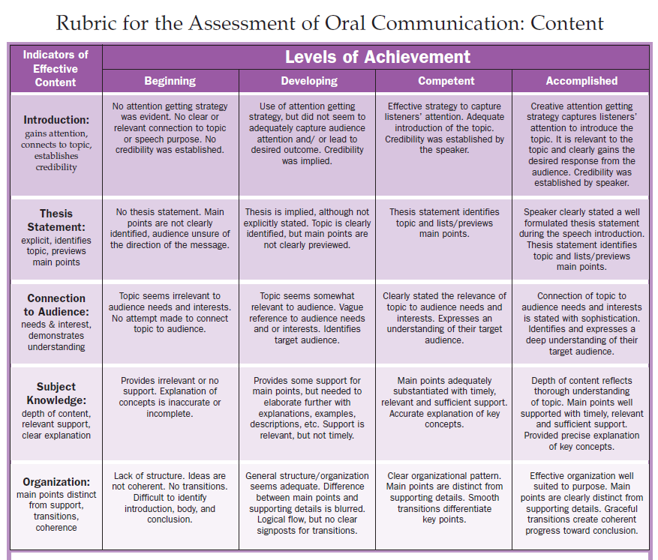

BUS 406 Delivery Rubric
