BSBA AY 2016-2017 Assessment
Phase 1: Assessment Plan
Learning Outcome assessed:
Learning Outcome 4:
Students will effectively communicate orally and in writing using various mediums across diverse situations.

Assessment Method:
Final presentation in BUS 406 was recorded and sent to two Rhetoric Instructors for separate evaluation of both teams and individuals.

Targeted performance, based on rubrics:
Our assessment target is that 80% of the students are competent or accomplished according to the rubric.
Evaluation Process:
Evaluators separately reviewed nine recorded presentations in BUS 406. The group was evaluated for content and organization, and then each individual presenter was evaluated for delivery.

Rubric:
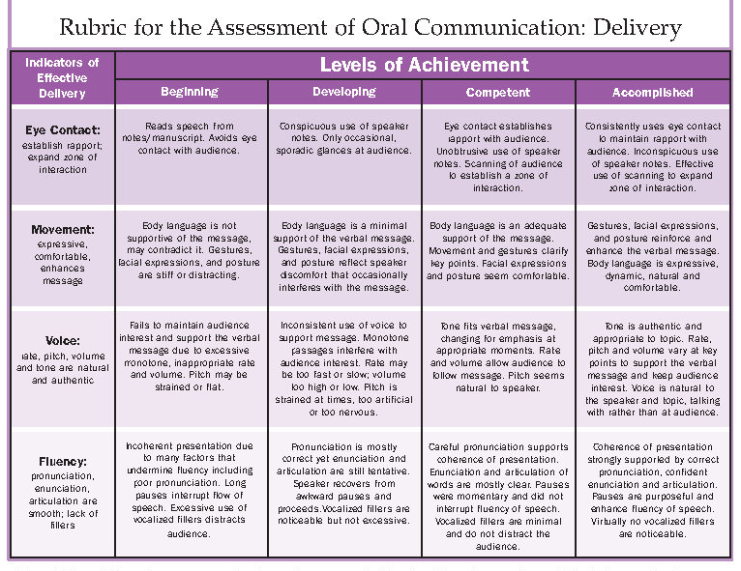

Course where learning outcome was assessed:
BSBA, BUS 406
Evaluator(s):
Jacquelyn Rae Horton
Michelle R LaVigne

Phase 2: Results Assessment and Planned Action
Results:
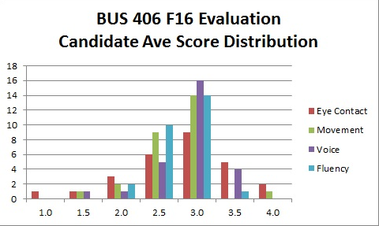

Suggested Action:
80% of the students should be at the competent or accomplished level. These skills are introduced outside of SOM, then reinforced in 304, and students should be accomplished by 401/406 (but they aren’t).

We need to identify where these skills are being reinforced and be tracking them. Deborah Panter’s office is starting to track these skills for WASC.

*Change target to meets equals competent/exceeds.

Phase 3: Closing the Loop

In the year that the assessment is made, this is good place to describe how the suggested actions might be evaluated in a future assessment cycle. When that cycle is complete, the results can be added to this document to finalize the report.

