MSFA AY 2016-2017 Assessment
Phase 1: Assessment Plan
Learning Outcome assessed:
2-3 Integration
Derivatives: Valuation Analyze the sources of value in derivative investments, including forwards, futures, options, and swaps, and demonstrate how derivatives are used to manage risk in the investment process.
Assessment Method:
Exam Question
Targeted performance, based on rubrics:
80% of students meet or exceed expectations
Evaluation Process:
Exam question with open-ended question.
Rubric:
Test key
Course where learning outcome was assessed:
MSFA 732-32, Derivatives II, 48 students
Evaluator(s):
Ivan Asensio

Phase 2: Results Assessment and Planned Action
Results:
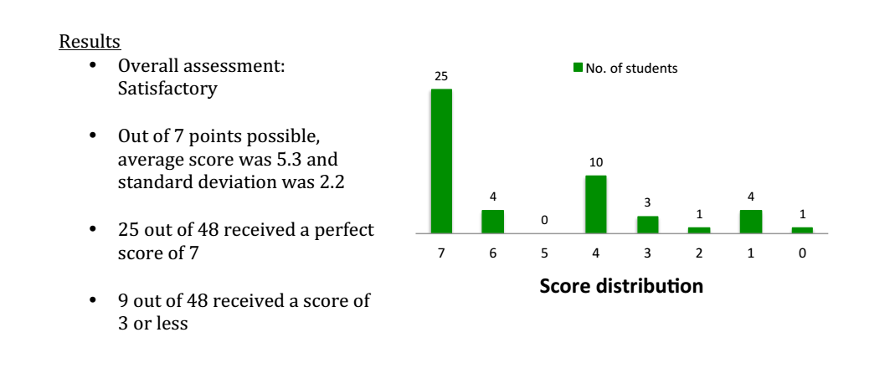
Target goal is 75% of student will perform at a level of 5/7 or better.
For this class we had 29/48 = 60%.
This class is on the cusp of attaining the goal for the course as 39/48 (81%) students attained 4/7 or better. So close to achieving goal.
Suggested Action:
It is clear that students need to improve by a small amount to attain the program’s target percentage in proficiency. The instructor will provide additional online study materials and additional practice questions on assignments to help the students on the margin improve.
We note that a glance at the questions on which these results are based shows that the questions are quite challenging and so we are not unhappy with the results achieved.

Phase 3: Closing the Loop

In future assessment cycles we may break out the LOS into “basic” vs. “advanced” skills in this LOS. This will allow us a better assessment of how students are mastering the skills in this LOS.

