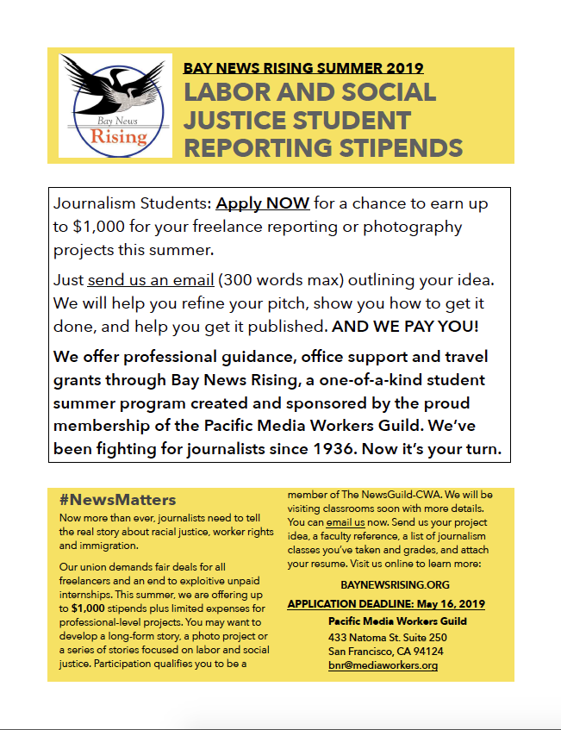

We hope you’re interested in Bay News Rising. The best way to get a sense of what we are looking for is to read the first four stories on the program’s web site. https://baynewsrising.org/
Those four stories – Mental health stigmas; London Breed and African-American voters; Immigrants facing deportation; and BART police – were written by students working with us during last summer’s Bay News Rising program. Notice that each of the stories required a good deal of reporting and research. But they are not so complex that they needed more than the approximately seven weeks of the program to complete.
Our mission is to encourage reporting on labor and issues of social justice. We define those fairly broadly, but we want to stay on message, so we will not consider stories that are focused on entertainment, the arts, or cultural issues.
The pitch should summarize your story proposal and give us an idea of how you propose to report it. In general, we are looking for stories focused on the Bay Area, but in some cases we can provide modest support for travel.
Please be sure your application contains the information mentioned in the flier.
This is a labor-intensive program. You’ll be asked to make regular progress reports and attend a few class sessions. There will be a good deal of back and forth between you and your mentor and a careful editing process. Based on our experience, the program needs to be your main focus during the summer. We understand that you may need to work, of course, but before you apply be certain that you have the time to participate fully.
Feel free to send us any questions that you may have.
Hope to hear from you soon.
Bill Snyder
Editor, Bay News Rising

